Molokai Hoe winner’s door open with 2014 champion out
By Kyle Galdeira

POSTED: 1:30 a.m. HST, Oct 11, 2015
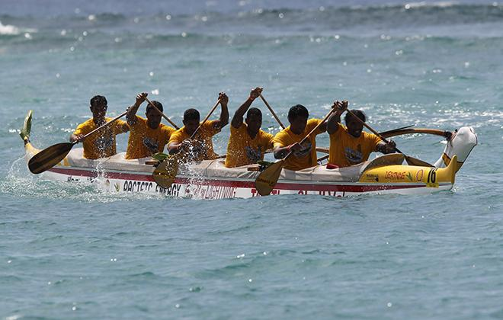
JAMM AQUINO / 2013
The Shell Va’a team won eight straight Molokai Hoe victories from 2006 to 2013.

While many aspects of the Molokai Hoe, including often unpredictable wind and ocean conditions, keep outrigger canoe paddlers and their supporters guessing every year, one thing is certain for the 63rd edition of the Molokai-to-Oahu world championship: A new champion will be crowned.
EDT Va'a, the Tahitian crew named after an energy company that won the prestigious Molokai Hoe last year, will not be back to defend its crown, race officials confirmed last week. While officials and rival paddlers would not go on record as to why EDT Va'a was foregoing the race, sources said the reason stemmed from a human resources issue, as the crew's paddlers are also employees of the company.
The absence of EDT opens the door for one of the 93 registered crews hitting the water today to take home the title after completing the 41-mile trek from Molokai's Hale O Lono Harbor to Duke Kahanamoku Beach in Waikiki. The field will feature crews from Brazil, Tahiti, Australia, the United Kingdom, California and Hawaii.
Shell Va'a, winner of eight consecutive Molokai Hoe championships prior to last year's runner-up effort, becomes the de facto favorite to start a new streak. Like their EDT Va'a countrymen, Shell's crew is composed of professional paddlers who work for the oil company. After winning their eighth straight crown in 2013, some Shell paddlers confidently proclaimed that they would continue chasing the world championship "until we die" and that the talented Tahitian paddlers needed to "win 10 in a row, then we can stop." Shell set the course record in 2011 in 4 hours, 30 minutes and 54 seconds -- nearly eight minutes faster than the previous record, which it also held.
Last year's EDT victory was made possible thanks to critical errors by Shell Va'a, which took an outside line while passing Kahala just prior to Diamond Head. After trailing by more than a quarter-mile as the crews neared Oahu, EDT Va'a took advantage of its counterpart's mistake and followed an inside line closer to shore that allowed the blue-clad paddlers to make up ground as the building tradewinds pushed Shell Va'a farther out to sea.
Sunday's international field also features a first-time competitor in Team Brazil, which is based in Sao Paulo and goes by "Samu." Brazil won the Liberty Challenge open division in New York on June 20.
"This is the first time Samu Team Brazil is coming and it's a chance of a lifetime -- we're super happy to be here and be part of this race," said Laercio Cito, the lone Team Brazil paddler based in Hawaii. "We practice year-round and canoe racing is really picking up in Brazil. The top outrigger paddling teams in Brazil earn funding from the government ... the country is looking to build more athletes and get them involved in the sport."
Na Koa O Kona, a Big Island-based crew that recently underwent a name change, claimed its second consecutive Henry Ayau Memorial Race title three weeks ago and affirmed its position as one of the teams to beat among the Hawaii competitors.
The victorious crew, whose name means Warriors of Kona, successfully navigated the 32-mile course from Maunalua Bay in Hawaii Kai to Nanakuli Beach Park and fended off Hui Nalu and Lanikai. The crew from Kona had formerly raced as Livestrong -- the namesake of embattled cyclist Lance Armstrong's charity -- then switched monikers to Mellow Johnny's, Armstrong's bicycle shop in Austin, Texas, before settling on Na Koa O Kona this year.
"We're all from Kona, live in the same area and raised our kids together," said Ikaika Hauanio, Na Koa O Kona's captain. "It's one big family. We're trying to represent where we come from and be more consistent."
Team Primo, which represents Maui's Wailea Canoe Club and set the record for the fastest time by a Hawaii competitor in 2011 (4:42:59), is another local crew expected to chase the championship. The crew garnered sixth place in 2014 and, since forming in 2009, has finished sixth or better every year.
Lanikai, the last Hawaii-based team to win the Molokai Hoe in 2005, was the top local finisher last year in fourth place.
"We have a bunch of next-generation kids who are training really hard and this season was a steppingstone," said Lanikai paddler Tapa Worthington, reflecting on last year's promising finish. "There's a lot more to come."
63RD ANNUAL HAWAIIAN AIRLINES MOLOKAI HOE
>> When: Today
>> Where: Hale O Lono Harbor, Molokai, to Waikiki Beach, Oahu (41 miles)
>> Race time: Race is scheduled to begin at 8 a.m., with the top finishers expected to finish around 12:45 p.m.
>> Recent champions: Tahiti's Shell Va'a claimed eight consecutive Molokai Hoe victories from 2006-2013. In 2014, Tahitian crew EDT Va'a, which is named for an energy company, upset Shell to win the title last year. Lanikai was the last locally based crew to claim the men's Molokai-to-Oahu hardware in 2005.
>> Record time: Shell Va'a set the event record time of 4 hours, 30 minutes and 54 seconds in 2011.

